**Qualitative fields (Dimensions):**

* Describes or categorizes data
* Tells you what, when, or who
* Slices the quantitative data

**Quantitative fields (Measures):**

* Numerical data
* Provides the measurement for qualitative category
* Can be used in calculations

**Fields in Tableau**

When Tableau connected to this data set, it assigned the fields to either Dimensions or Measures.

* The qualitative fields that describe categories of data are in the top part of the pane, under **Dimensions**.
* The quantitative fields that measure categories of data are in the bottom part of the pane, under **Measures**.

**Data granularity**: refers to the level of detail for a piece of data, wherever you are looking. As data becomes less granular, we might describe it as an aggregation, or as aggregated data.  Aggregation refers to how data is combined. The level of granularity or aggregation in a row or chart affects the questions we can ask of the data, and the discoveries we can make.

When you move dimensions and measures in and out of a view, the view's level of detail changes.

* By default, measures placed in a view are aggregated by SUM, which means that the data for that field in all of the rows is combined.
* Measures can also be aggregated as average, median, count, or count distinct.
* Dimensions break down the aggregated total into smaller totals by category.

The "Aggregation, Granularity, and Ratio Calculations" video from Tableau goes into more detail about aggregation and data granularity. It uses the example of looking at profit ratios and can help you understand the behavior of Tableau charts.

**Why use data visualizations?**

**Visualizations help us understand complex data**

The best reason to use a visualization to understand your data is that most data sets are far too large to consume in their raw format. Humans are limited in what information we can process and compare in our heads, especially if that information resides in a million row data set, but we are good at quickly processing visual information.

Even if you are new to reading data in a chart, you already have the built-in capabilities to spot light and dark colors, large and small shapes, groups and orientations of objects. These are referred to as pre-attentive attributes.

* Visual analytics leverages our pre‑attentive attributes – visual cues humans process automatically with sensory memory.
* We can notice and interpret these kinds of attributes quickly and without special effort.

Module 2. Reading Common Chart Types

**Bar charts with an axis not including zero (0)**

An axis without a zero can be misleading on a bar chart, as it can distort the scale of differences between categorical data.

**Color confusion**

Color is an effective tool for drawing attention to or differentiating areas of data, but can cause confusion if not used carefully. For example, we usually associate density in maps with a darker color, but if the author reverses the color range, that can be confusing, and even misleading.

**Wrong chart type for the data**

Not all chart types work for the selected dimensions and measures.

**Line chart:**

**Line** — View trends in data over time.

**Examples:**  Stock price change over a five-year period or website page views during a month.

**Bar Chart:**

**Bar** — Compare data across categories.

**Examples:** Volume of shirts in different sizes, or percent of spending by department.

**Heat Map Chart:**

**Heat Map** — Show the relationship between two factors.

**Examples:** Segment analysis of target market, or sales leads by individual rep.

**Highlight Table Chart:**

**Highlight Table** — Shows detailed information on heat maps.

**Examples:** The percent of a market for different segments, or sales numbers in a  region.

**Treemap Chart:**

**Treemap**— Show hierarchical data as a proportion of a whole.

**Examples:**Storage usage across computer machines, comparing fiscal budgets between years.

**Gantt Chart:**

**Gantt** — Show duration over time.

**Examples:** Project timeline, duration of a machine’s use, availability of players on a team.

**Bullet Chart:**

**Bullet**— Evaluate performance of a metric against a goal.

**Examples:** Sales quota assessment,  performance spectrum (great/good/poor).

**Scatterplot:**

**Scatterplot**— Investigate relationships between quantitative values.

**Examples:**Male versus female likelihood of having lung cancer at different ages, or technology early adopters’ and laggards’ purchase patterns of smart phones.

**Histogram**— Understand the distribution of your data.

**Examples:** Number of customers by company size, student performance on an exam, frequency of a product defect.

**Symbol maps** — Use for totals rather than rates. Be careful, as small differences will be hard to see.

**Examples:** Number of customers in different geographies.

**Area maps** — Use for rates rather than totals. Use sensible base geography. **Examples:** Rates of internet-usage in certain geographies, house prices in different neighborhoods.

**Box Plot:**

**Box-and-Whisker** — Show the distribution of a set of a data.

**Examples:** Understanding your data at a glance, seeing how data is skewed towards one end, identifying outliers in your data.

A BAR CHART is used to compare data across categories. Just like the cross-tab, bar charts are a very recognizable chart type, and if done well, are easy to read and interpret.

* The length of the bars tells you which category has the highest value.
* The axis of the bar chart indicates what that value represents.

Sometimes, *if the bar chart is clear and labeled*, the author removes the axis header to reduce visual clutter. In Tableau, an author might do this if the intention is to use the chart as a filter for other data, or to provide a high-level status. When you see a bar chart without an axis, ask:

* Is the chart labeled clearly?
* Can I determine the range of values?

Line charts: Viewing data over time

**Looking for trends over time**

Line charts are especially useful for viewing changes in data over time. Are sales going up or down, and by how much? Are there seasonal trends?

A line chart can include a single set of values, like this chart below showing monthly sales for an office supply company over the course of a single year:

When you are looking at a line chart, watch for the following:

* When do trends rise and fall?
* Do any of the data allow you to identify or predict future trends?
* Pay attention to the axis - What is the typical range of values? Are the intervals uniform?
* What is the timeline: yearly? monthly? daily? Does the chart show the right amount of detail for your analysis?

# Scatter plots: Viewing data relationships and outliers

Use scatter plots to determine correlation between two measures.Correlation refers to a relationship between two or more things.

"correlation does not mean causation." When you find a correlation between two data points, you can't assume with certainty that one event causes the other without additional data and observation. Correlation between variables means a relationship exists, but causation indicates one actually causes a change in the other.

## Outliers:

Even when a correlation is shown in a scatter plot, sometimes there may be values that diverge from the trend, known as outliers.

Outliers can be interesting and should be investigated so you know how to interpret them. Are they rare exceptions that can be disregarded? Or an indication of something to examine more closely? Or maybe they're simply errors in recording or transcription? To be sure, examine the underlying data to make your determination.

**Questions that Lead to Viewing Correlations**

When deciding whether you need a scatter plot, consider the following questions:

* Will the user be interested in whether a variable increases or decreases with the changes in another variable?
* Will the user be interested in determining whether a change to one variable has an effect on another variable and what that effect is?
* Will the user need to know how closely a variable follows the changes to another variable?

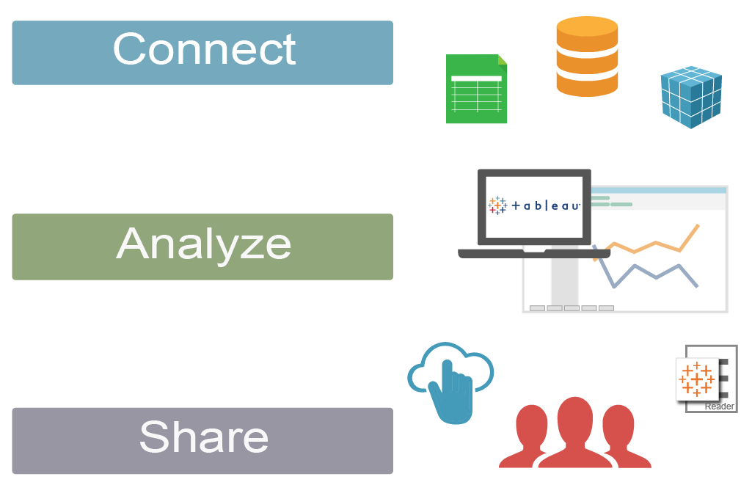

.twb – only visualization

.twbx – viz+data source (flat files) {for oth data srcs extract should be done}

How Tableau Desktop Connects to Data:

* 1. Live
  2. Extract

.tds -> tableau datasouse file

Updating the View with New Data:

* Data updates are automatically loaded.
* Schema(rename cols) updates will create issues. **Replace References** is used. Adding columns is handled.

.tds -- Data connection info , metadata edits, Cal fields are stored

Updating the View with New Data:

Creating Filters on Your Data:

* Tableau uses “AND” Logic to apply filters to a dimensions or to to multiple fields

 Changing Filter Options:

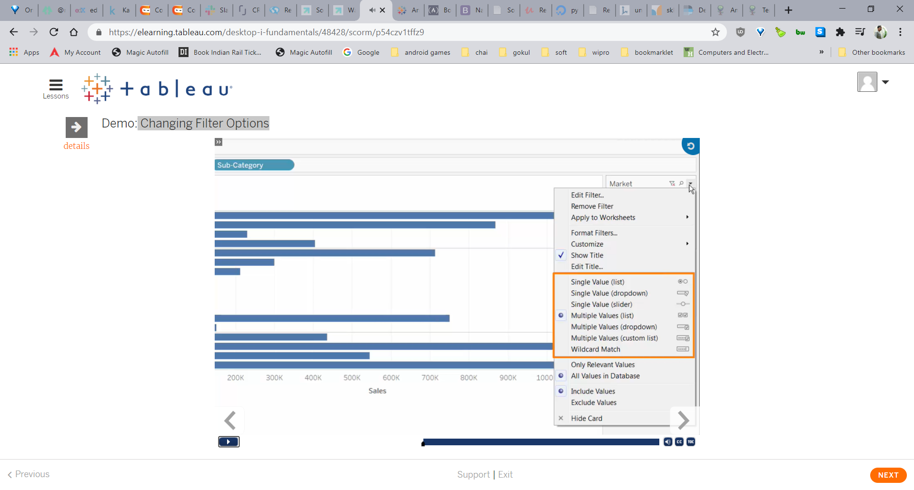

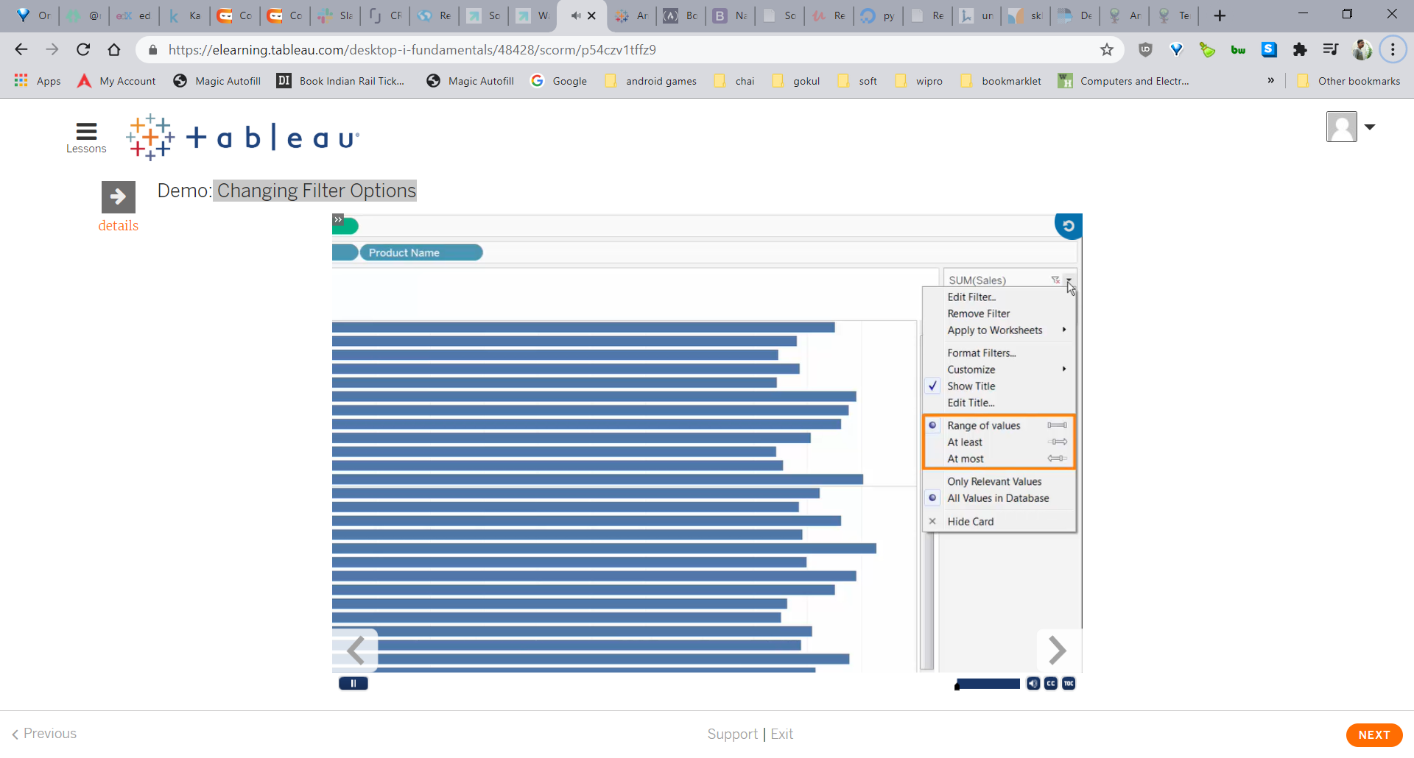

Using Date Filters:

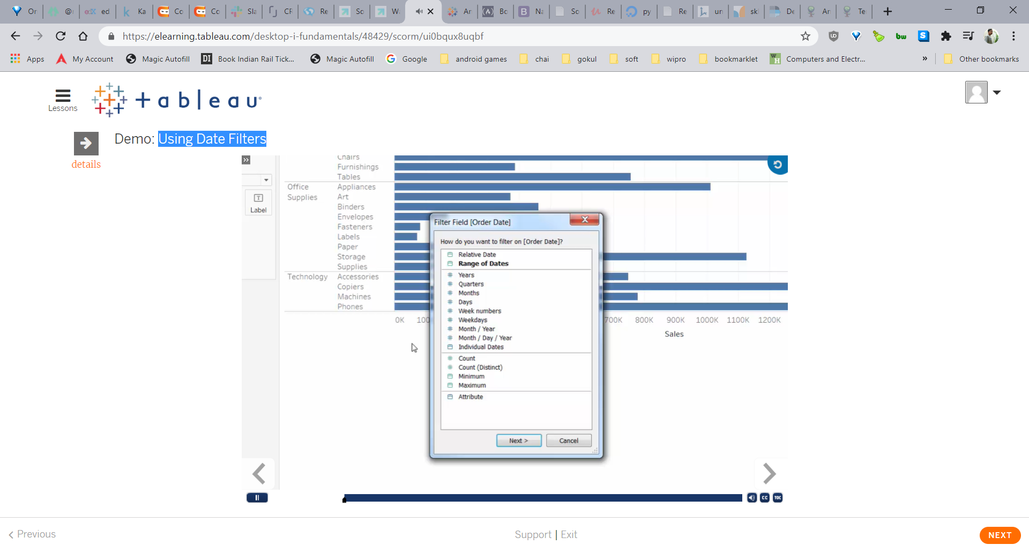

Figure : Date filter using datepart

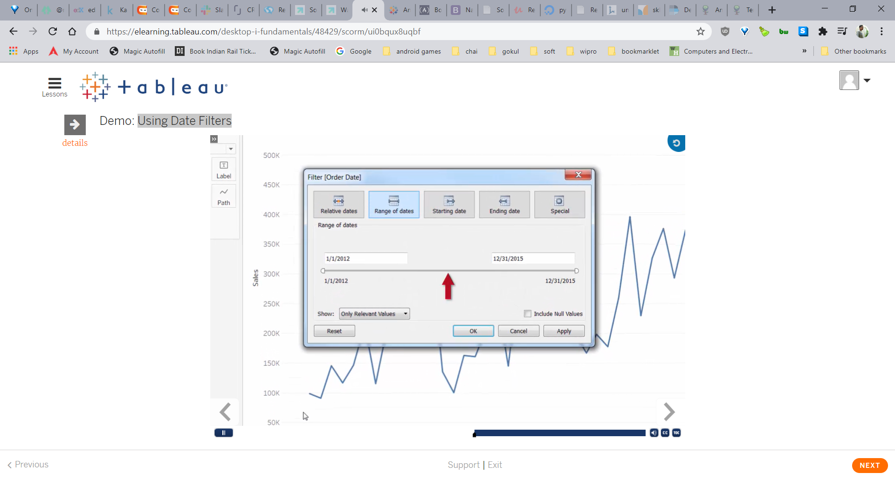

Figure : insert date filter using daterange

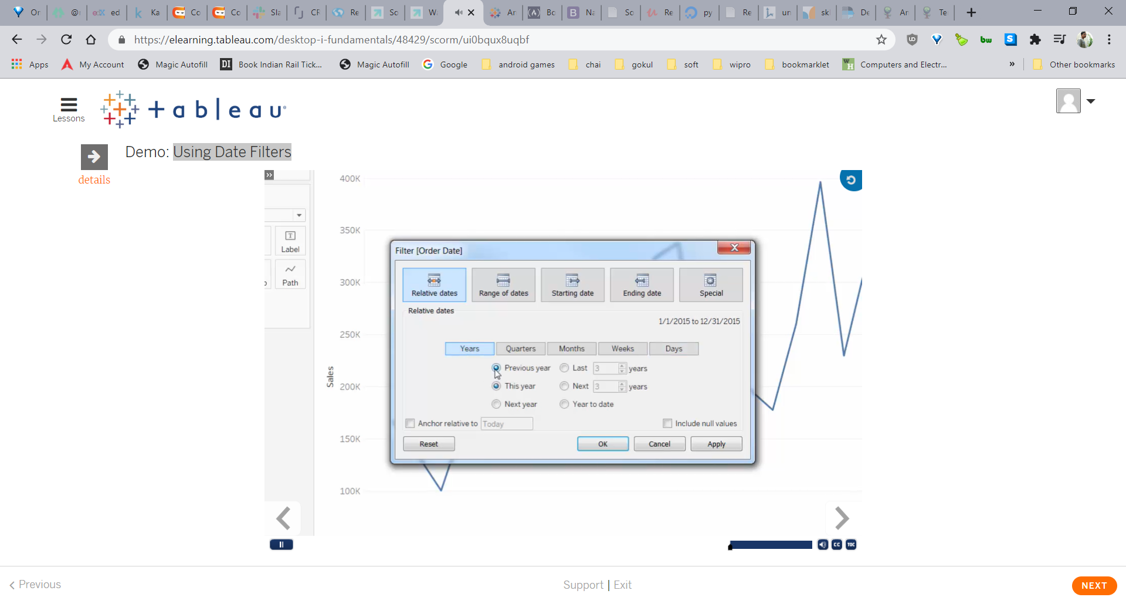

Figure Insert date filter using relative dates relative to anchor date.

Sorting Your Data to Find Answers:

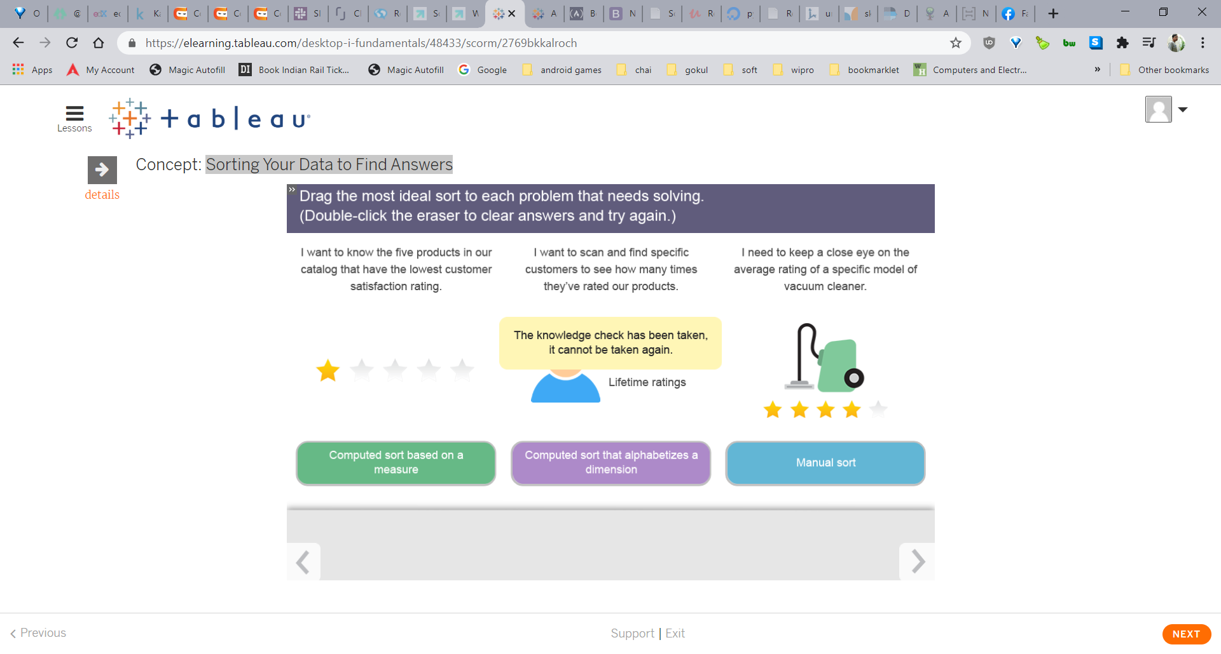

Using Computed and Manual Sorts:

Organizing Your Data with Groups:

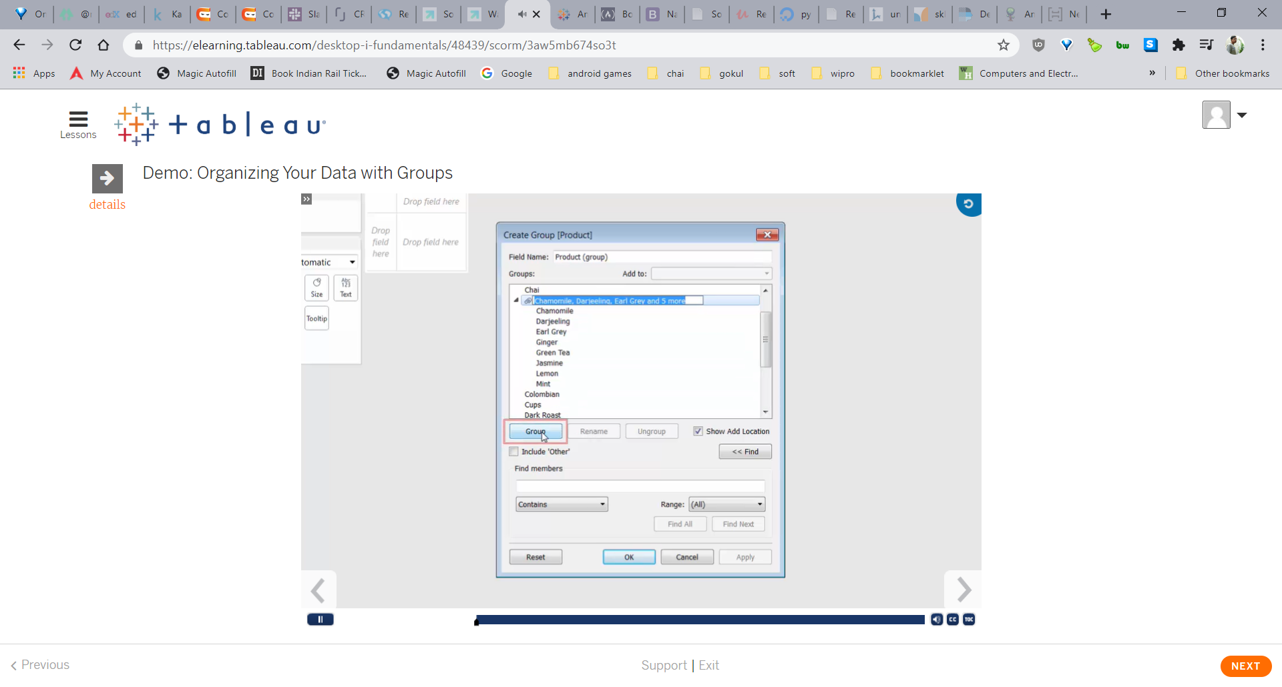

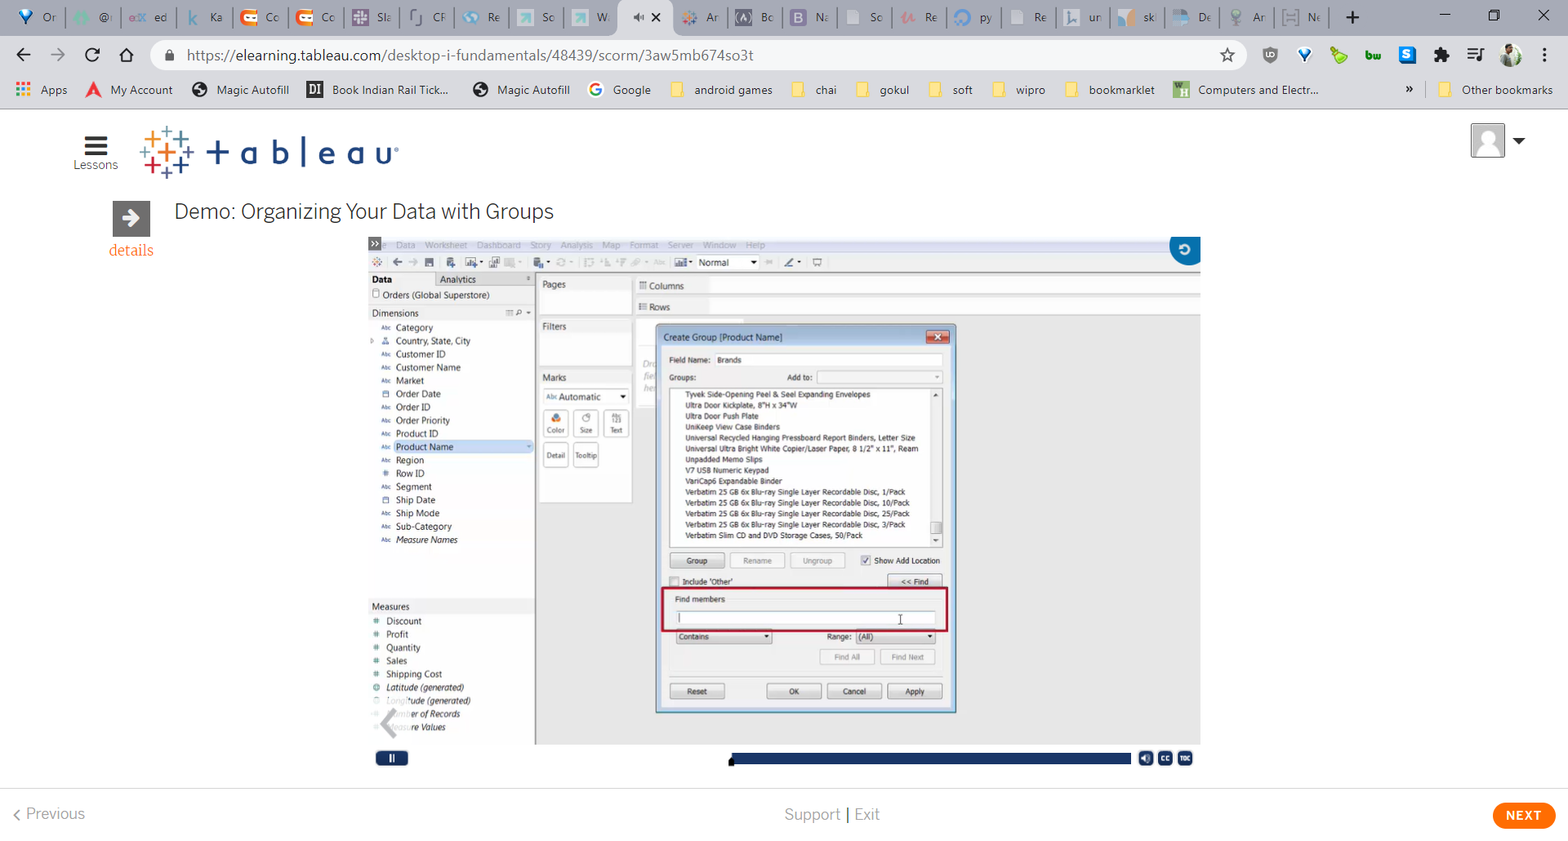

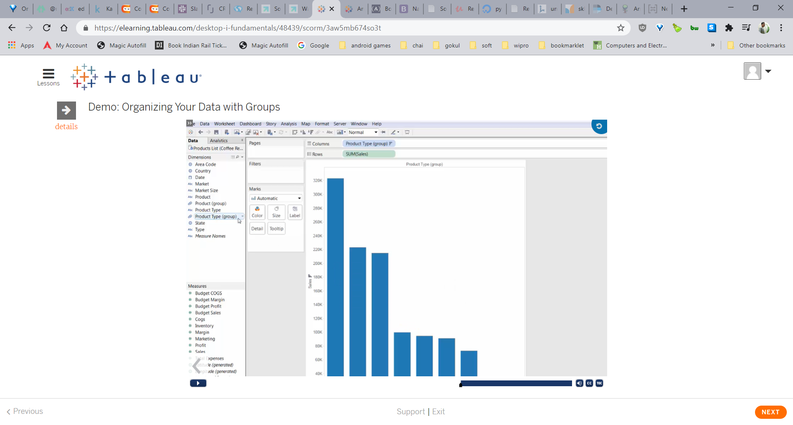

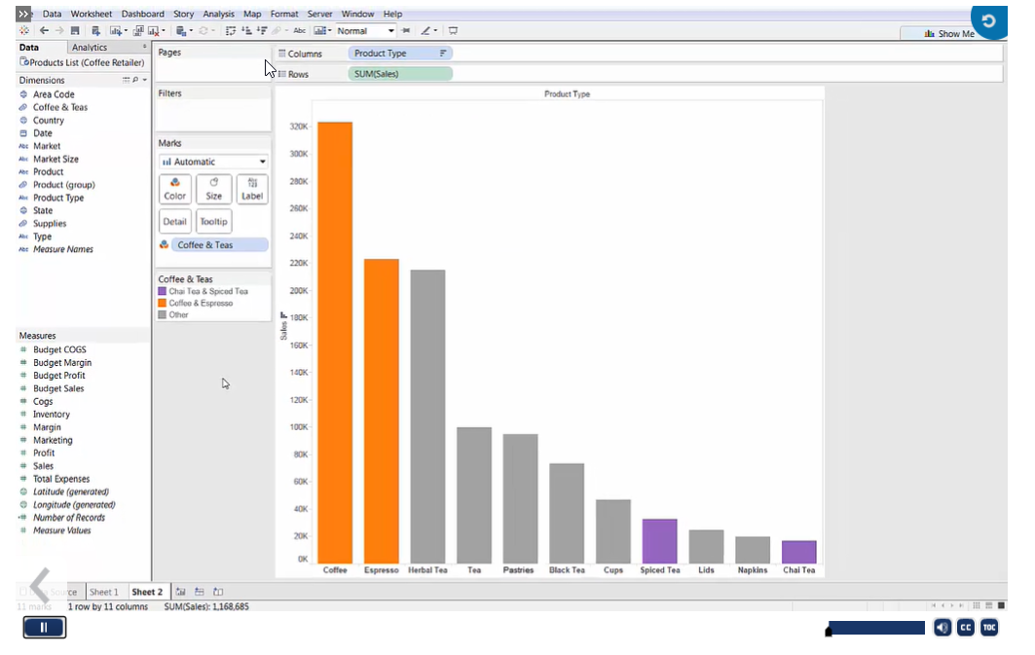

Organizing Your Data with Hierarchies:

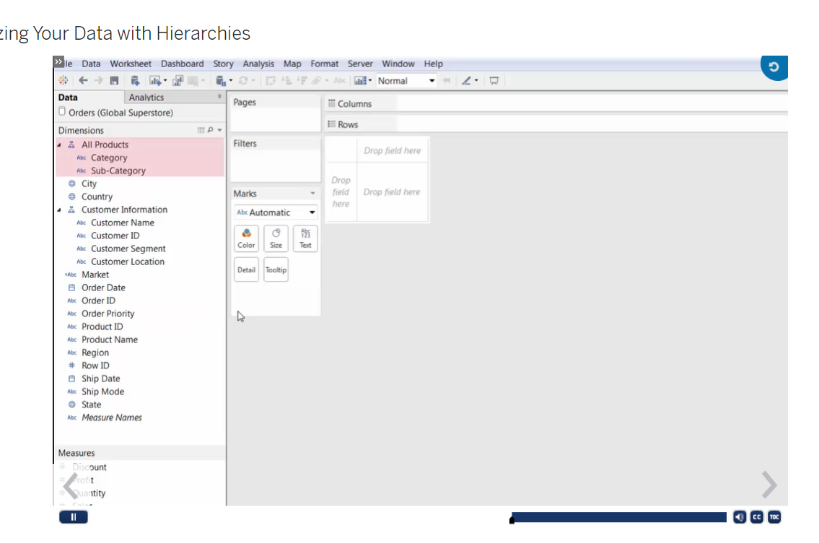

Working with Dates:

Working with Dates:

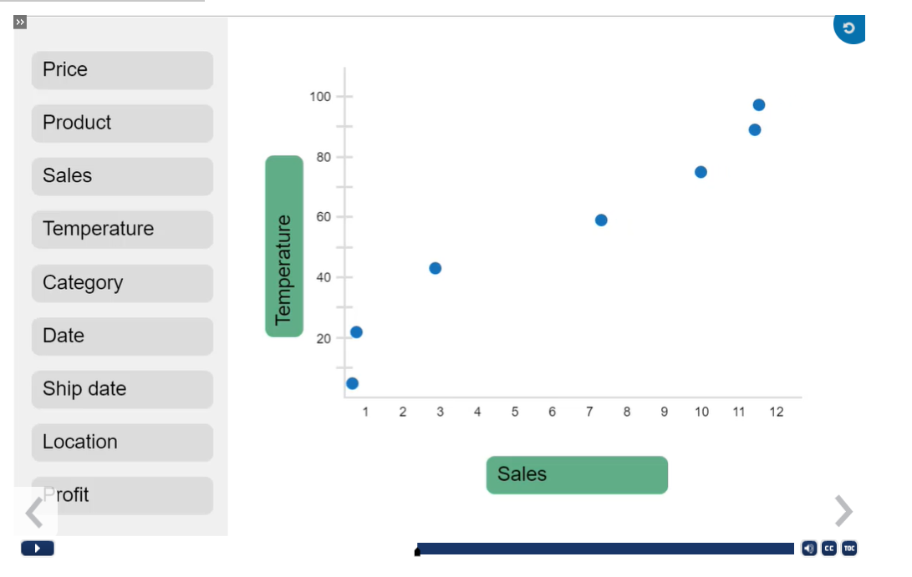

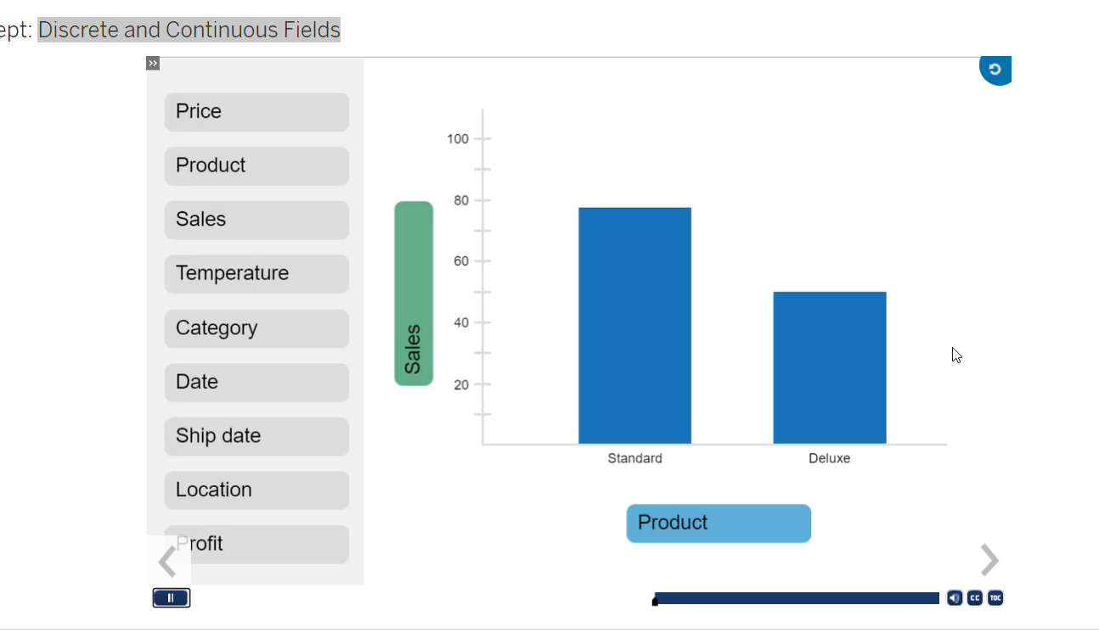

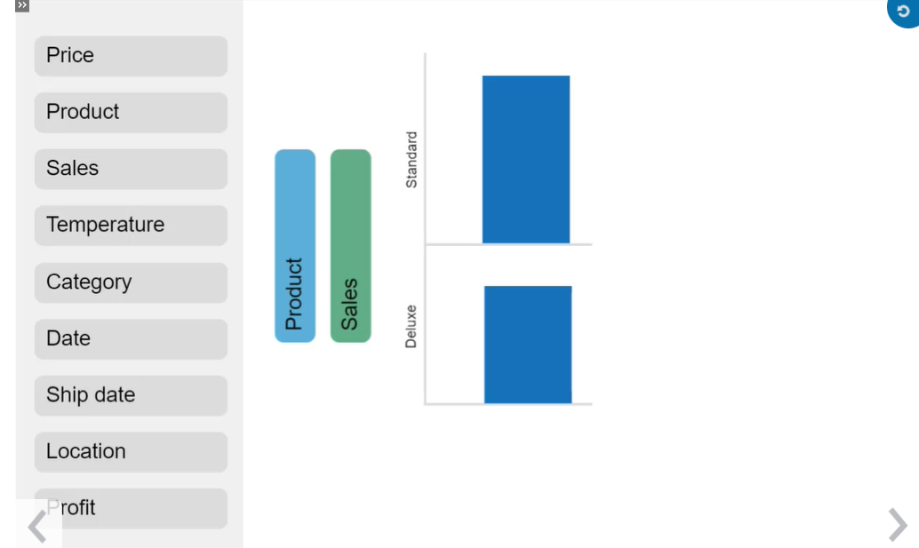

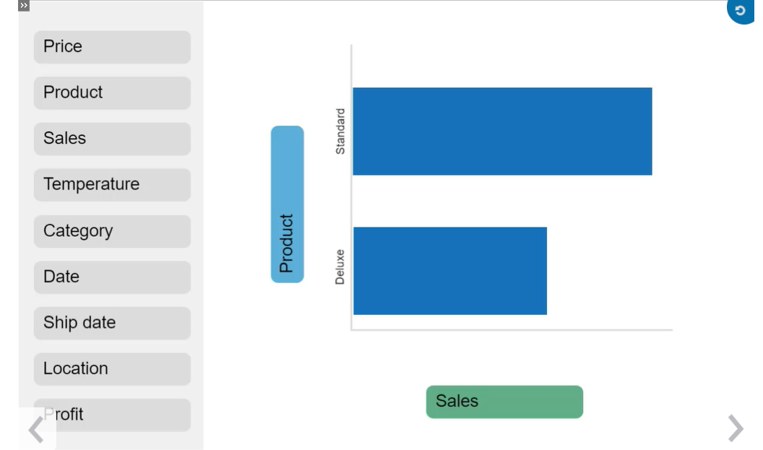

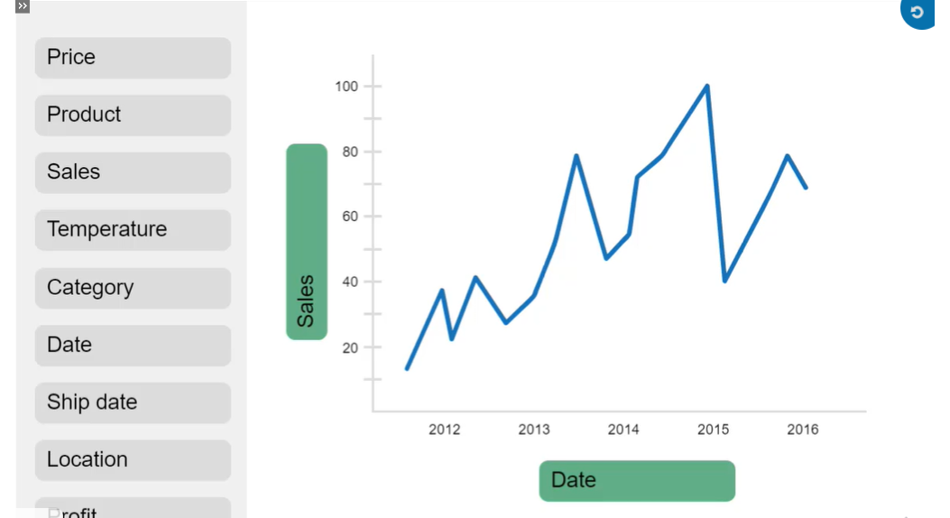

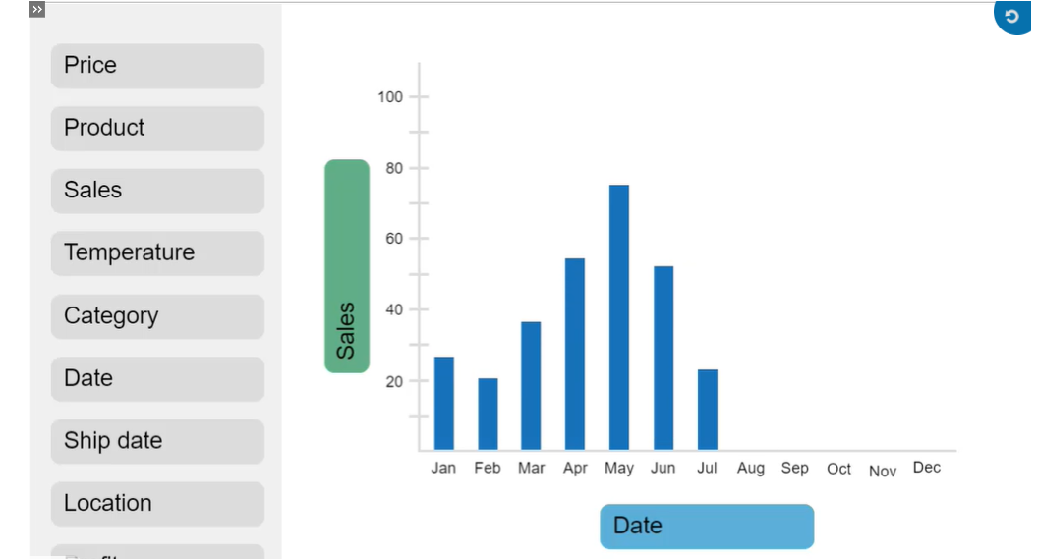

Time(Continuous): over time. Date Value

Time(discrete): DatePart

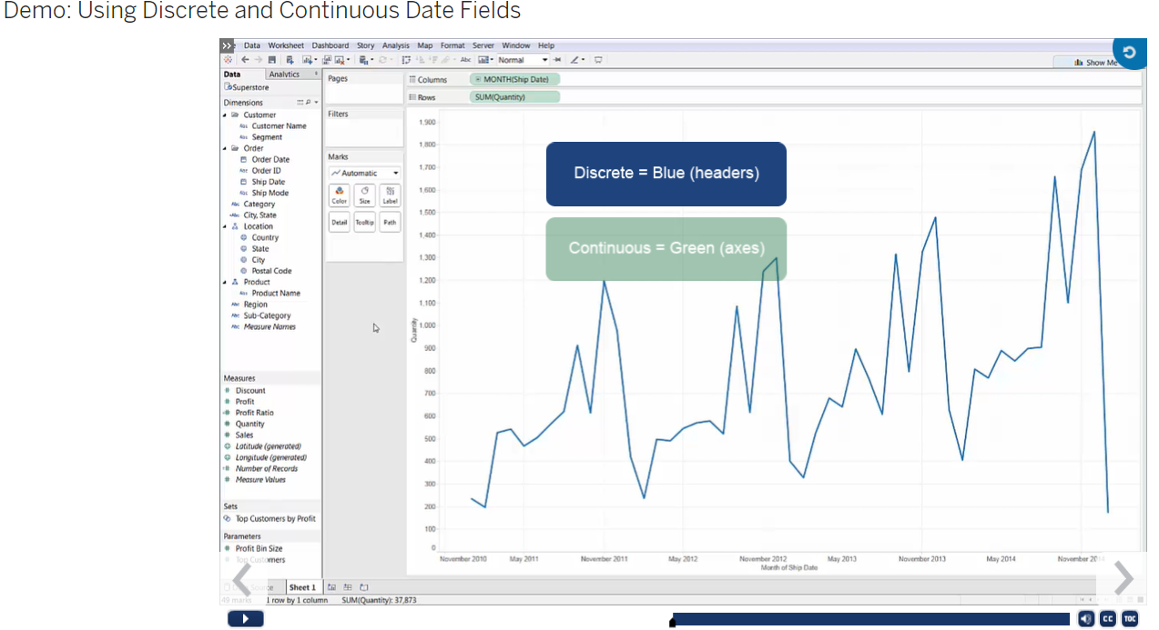

Creating Custom Dates:

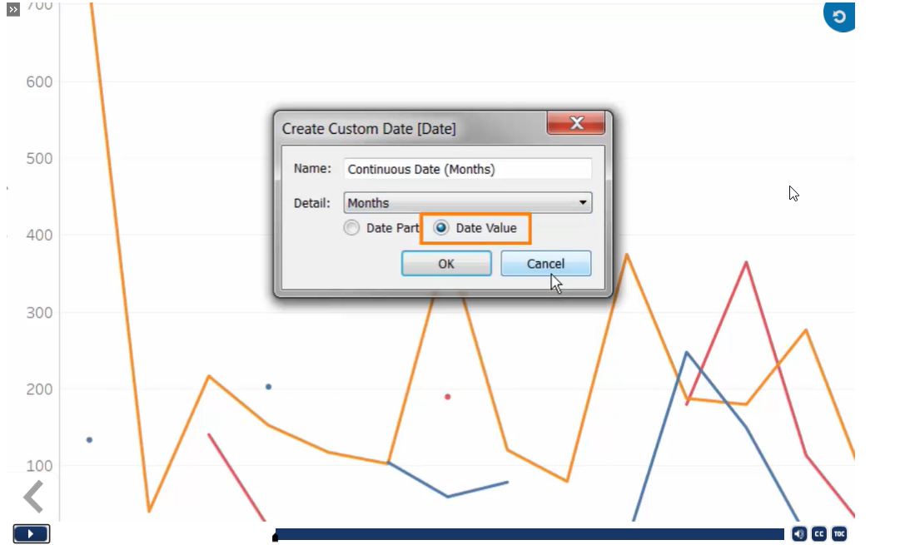

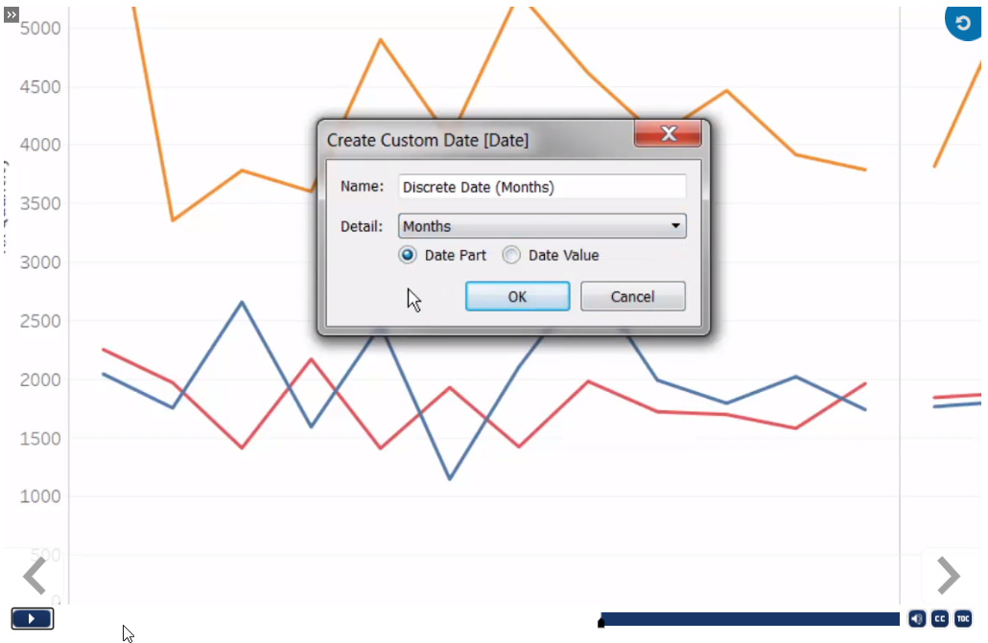

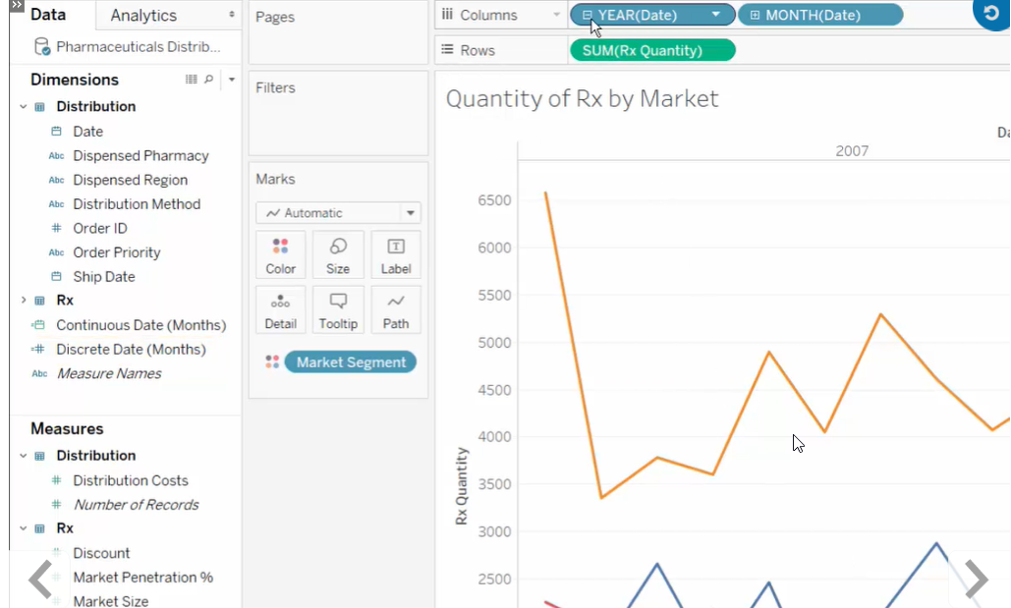

Building Dual Axis and Combo Charts:

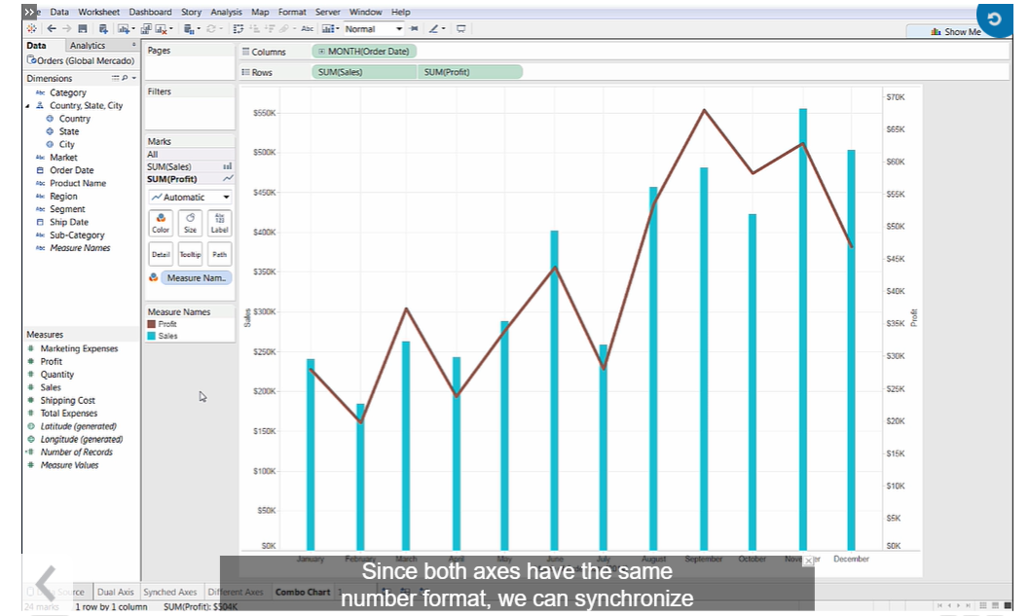

Building a Combined Axis Chart:

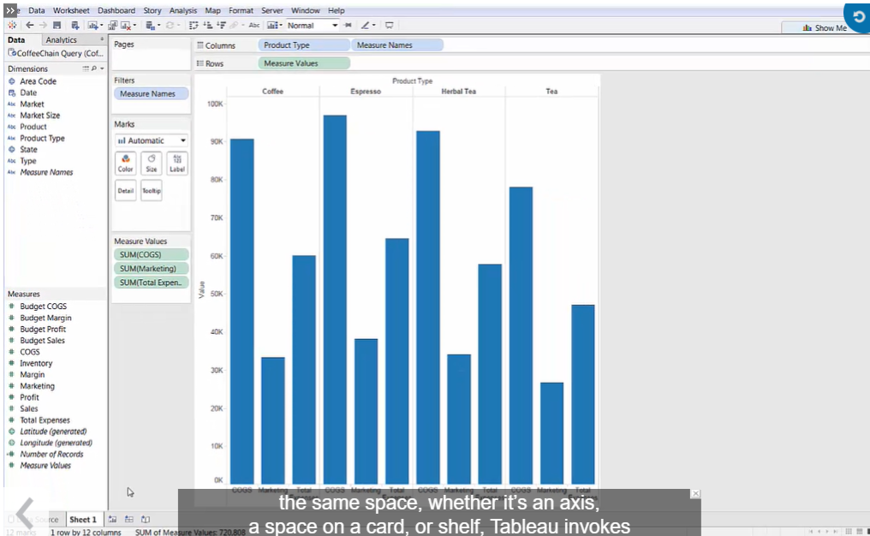

* + After removing measure names pill

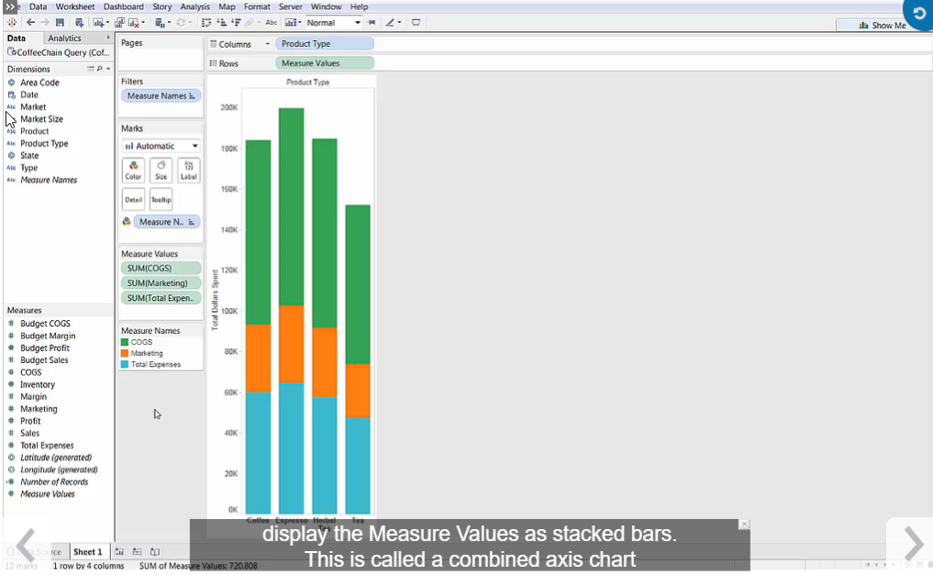

Mapping Your Data:

1. Symbol Maps
2. Filled Maps

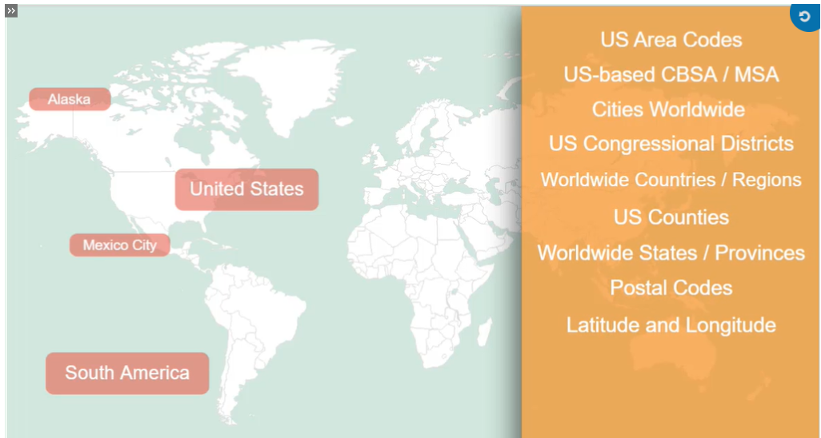

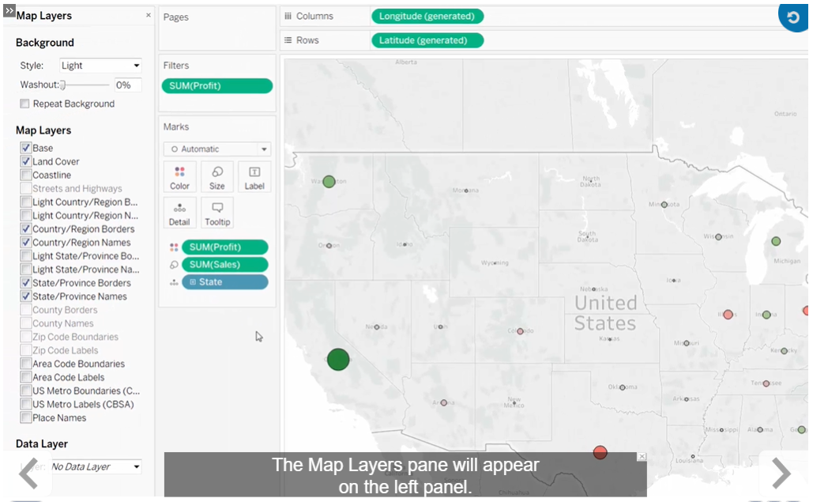

Creating and Editing Crosstabs :

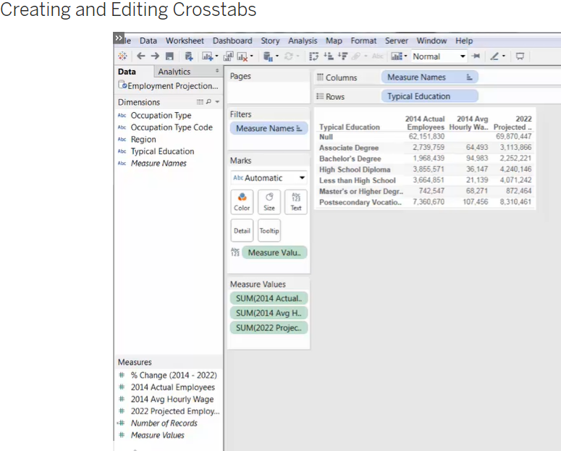

## **Working with Totals and Aggregation**

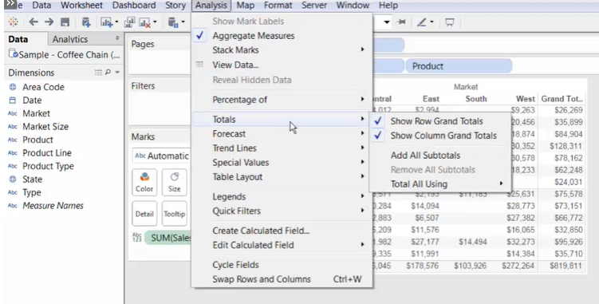

Creating Highlight Tables :

 Creating Heat Maps:

Using Calculated Fields:

